4.2 Subspaces
A subset W of a vector space V is called a subspace of V if W is itself a vector space under the addition and scalar multiplication defined on V.
In general, to show that a nonempty set W with two operations is a vector space one must verify the ten vector space axioms. However, if W is a subspace of a vector space V, then certain axioms need not be verified because they are “inherited” from V. For example, it is not necessary to verify that $\vec{u}+\vec{v }=\vec{v}+\vec{u }$ holds in W
because it holds for all vectors in V including those in W. On the other hand, it is necessary to verify that W is closed under addition and scalar multiplication since it is possible that adding two vectors in W or multiplying a vector in W by a scalar produces a vector in V that is outside of W.
Those axioms that are not inherited by W are:
Axiom 1—Closure of W under addition
Axiom 4—Existence of a zero vector in W
Axiom 5—Existence of a negative in W for every vector in W
Axiom 6—Closure of W under scalar multiplication
so these must be verified to prove that it is a subspace of V. However, the following theorem shows that if Axiom 1 and Axiom 6 hold in W, then Axioms 4 and 5 hold in W as a consequence and hence need not be verified.

THEOREM 4.2.1
If W is the subset of a vector space V, then W is called subspace if and only if the following conditions hold:
- (Closed under addition) If $\vec{u}$ and $\vec{v}$ are vectors in W, then $\vec{u}+\vec{v}$ is in W.
- (Closed under scalar multiplication) If k is any scalar and $\vec{u}$ is any vector in W then $k\vec{u}$ is in W.
Or in other words, W is subspace of V if and only if it is closed under addition and scalar multiplication.
Note that every vector space has at least two subspaces, itself and its zero subspace.

Example 1: If V is any vector space and if $W=\{\vec{0}\}$ is the subset of V that consists of the zero vector only, then W is closed under addition and scalar multiplication since
$$\vec{0}+\vec{0}=\vec{0}$$
$k\vec{0}=\vec{0},$ for any scalar k
We call W the zero subspace of V.
Example 2:
$$W=\{\left(x,y\right);x≥0, y≥0\}$$
Prove and disprove W is subspace of $R^{2}.$
Solution:
- W is closed under addition, because
Let, $\vec{u}=\left(x, y\right), \vec{v }=\left(x^{'}, y^{'}\right)∈W$ $(x,y≥0 and x^{'},y^{'}≥0)$
$\vec{u}+\vec{v }=\left(x+x^{'}, y+y^{'}\right)∈W$ $(x+x^{'}≥0 and y+y^{'}≥0)$
- W is not closed under scalar multiplication, because if
$$\vec{u}=\left(1,1\right)∈W$$
But $-\vec{u}=\left(-1,-1\right)∉W$
So W is not subspace of V.

Example 3:
Which of the following subset of $R^{2}$ with usual operations of addition and scalar multiplication are subspaces?
- $W_{1}=\left\{\left(x,y\right);x≥0\right\}$
- $W_{2}=\{\left(0,y\right);y∈R\}$
Solution:
- $W_{1}$ is closed under addition but not closed under scalar multiplication, because
$$Let \vec{u}=\left(2,3\right)∈W$$
$$and \left(-2\right)\vec{u}=-2\left(2,3\right)=\left(-4,-6\right)∉W$$
- $W_{3}=\{\left(0,y\right);y∈R\}$
As $W_{3}=y-axis$ in $R^{2}$. To see whether $W_{3}$ is subspace , Let
$$\vec{u}=\left(0,u_{1}\right),\vec{v}=\left(0,v_{1}\right)∈W_{3}$$
$$\vec{u}+\vec{v}=\left(0,u_{1}+v_{1}\right)∈W_{3},$$
$W_{3}$ is closed under addition.
Let $\vec{u}=(0, u_{1})$, k is any scalar then
$$k\vec{u}=\left(0,ku_{1}\right)∈W_{3}$$
$W_{3}$ is closed under scalar multiplication.
$∴W_{3}$ is subspace of $R^{2}$.

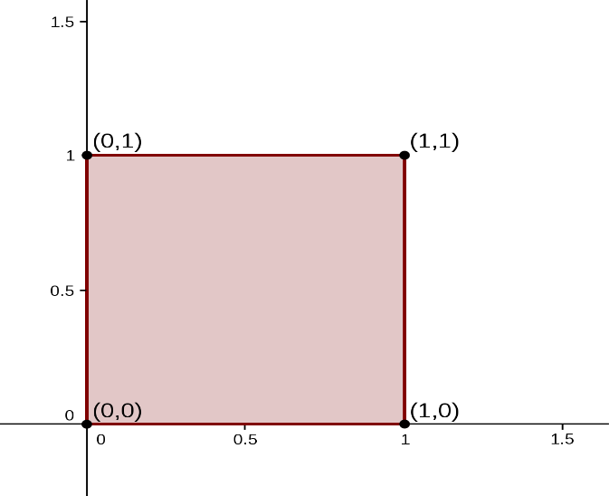
Example 4.
Consider the unit square shown in the accompanying figure. Let W be the set of the form $\left[\begin{aligned}x \\ y\end{aligned}\right]$, where $0≤x≤1, 0≤y≤1$. That is W is the set of all vectors whose tail is at origin and whose head is a point inside or on the square. Is W a subspace of $R^{2}$? Explain.
Solution:
Let $\vec{u}=\left(0,1\right),\vec{v}=\left(1,1\right)∈W.$
Then $\vec{u}+\vec{v}=\left(1,2\right)∉W.$
W is not closed under addition.
W is not subspace of $R^{2}.$
Example 5.
Which of the given subsets of the vector space $M_{23}$ of all $2×3$ matrices are subspace? The set of all matrices of the form?
- $W_{1}=\left\{\left[\begin{matrix}a & b & c \\ d & 0 & 0\end{matrix}\right];where b=a+c\right\}$
- $W_{2}=\left\{\left[\begin{matrix}a & b & c \\ d & 0 & 0\end{matrix}\right];where c>0\right\}$
- $W_{3}=\left\{\left[\begin{matrix}a & b & c \\ d & e & f\end{matrix}\right];where a=-2c, f=2c+d\right\}$
Solution:
Do it your self

Exercise 4.2
Q1. Which of the following subset of $R^{3}$ with usual operations of addition and scalar multiplication are subspaces?
- $W_{1}=$ All vectors of the form $(a, 0, 0)$
- $W_{2}=$ All vectors of the form $(a, 1, 1)$
- $W_{3}=$ All vectors of the form $\left(a, b,c\right)$ where $b=a+c.$
- $W_{4}=$ All vectors of the form $\left(a, b,c\right)$ where $b=a+c+1.$
- $W_{5}=$ All vectors of the form $\left(a, b,0\right)$ .
Solution:
- $W_{1}=\left\{\left(a, 0, 0\right);a∈R\right\}$
- $W_{1}$ is closed under addition and scalar multiplication as:
$$\vec{u}=\left(a_{1}, 0, 0\right)∈W_{1}$$
$$\vec{v}=\left(a_{2}, 0, 0\right)∈W_{1}$$
$$\vec{u}+\vec{v}=\left(a_{1}+a_{2}, 0, 0\right)∈W_{1}$$
- Let$\vec{u}=\left(a_{1}, 0, 0\right)∈W_{1}$ and k is any scalar, then
$$k\vec{u}=\left(ka_{1}, 0, 0\right)∈W_{1}$$
$W_{1}$ is subspace of $R^{3}$.

- $W_{2}=\left\{\left(a, 1, 1\right);a∈R\right\}$
Let’s check the first property, i.e.$W_{2}$ is closed under addition. For
$$\vec{u}=\left(a_{1}, 1, 1\right)∈W_{2}$$
$$\vec{v}=\left(a_{2}, 1, 1\right)∈W_{2}$$
$$\vec{u}+\vec{v}=\left(a_{1}+a_{2}, 2,2\right)∉W_{2}$$
$W_{2}$ is not subspace of $R^{3}$.

- $W_{3}=\left\{\left(a, b, c\right);b=a+c;a, b, c∈R\right\}$
- $W_{1}$ is closed under addition and scalar multiplication as:
$$\vec{u}=\left(a_{1}, b_{1}, c_{1}\right)=(a_{1},a_{1}+c_{1}, c_{1})∈W_{3}$$
$$\vec{v}=\left(a_{2}, b_{2}, c_{2}\right)=(a_{2}, a_{2}+c_{2}, c_{2})∈W_{3}$$
Then $\vec{u}+\vec{v}=\left(a_{1}+a_{2}, \left(a_{1}+c_{1}\right)+\left(a_{2}+c_{2}\right), c_{1}+c_{2}\right)$
$$\vec{u}+\vec{v}=\left(a_{1}+a_{2}, a_{1}+a_{2}+c_{1}+c_{2}, c_{1}+c_{2}\right)∈W_{3}$$
So $W_{3}$ is closed under addition.
- Let$\vec{u}=\left(a_{1}, a_{1}+c_{1}, c_{1}\right)∈W_{3}$ and k is any scalar, then
$$k\vec{u}=k\left(a_{1}, a_{1}+c_{1}, c_{1}\right)=\left(ka_{1}, k\left(a_{1}+c_{1}\right), kc_{1}\right)$$
$$=\left(ka_{1}, ka_{1}+kc_{1}, kc_{1}\right)∈W_{3}$$
$W_{3}$ is closed under scalar multiplication.
So, $W_{3}$is subspace.
- $W_{4}=$ All vectors of the form $\left(a, b,c\right)$ where $b=a+c+1.$
$$\vec{u}=\left(a_{1}, b_{1}, c_{1}\right)=(a_{1},a_{1}+c_{1}+1, c_{1})∈W_{4}$$
$$\vec{v}=\left(a_{2}, b_{2}, c_{2}\right)=(a_{2}, a_{2}+c_{2}+1, c_{2})∈W_{4}$$
Then $\vec{u}+\vec{v}=\left(a_{1}+a_{2}, \left(a_{1}+c_{1}\right)+\left(a_{2}+c_{2}\right)+2, c_{1}+c_{2}\right)$
$$\vec{u}+\vec{v}=\left(a_{1}+a_{2}, a_{1}+a_{2}+c_{1}+c_{2}+2, c_{1}+c_{2}\right)∉W_{4}$$
So $W_{4}$ is not closed under addition.
So $W_{4}$ is not subspace of $R^{2}.$
- $W_{5}=$ All vectors of the form $\left(a, b,0\right)$ .
$$Solution:$$

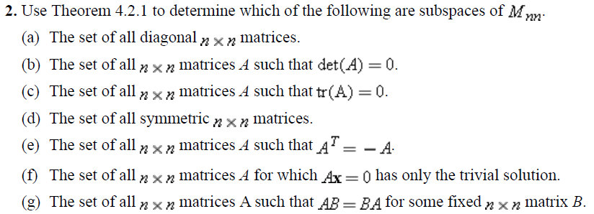

Polynomials of degree $≤$n:
$$P\left(t\right)=a_{n}t^{n}+a_{n-1}t^{n-1}+…+a_{1}t+a_{0}; a_{n}, a_{n-1}, a_{n}, …, a_{1}, a_{0}∈R and a_{n}≠0$$
Let $P_{n}$ be the set of all polynomials of degree n, form vector space under addition and scalar multiplication defined by:
$$p\left(t\right)=a_{n}t^{n}+a_{n-1}t^{n-1}+…+a_{1}t+a_{0}$$
$$q\left(t\right)=b_{n}t^{n}+b_{n-1}t^{n-1}+…+b_{1}t+b_{0}$$
$$p\left(t\right)+q\left(t\right)={(a}_{n}+b_{n})t^{n}+{(a}_{n-1}+b_{n-1})t^{n-1}+…+\left(a_{1}+b_{1}\right)t+{(a}_{0}+b_{0})$$
If k is any scalar then
$$kp\left(t\right)=k(a_{n})t^{n}+k(a_{n-1})t^{n-1}+…+k(a_{1})t+{k(a}_{0})$$
Then $P_{n}$ is vector space.

